BUS MANAGEMENT SYSTEM – PROJECT REPORT
1. Title Page
Title: Bus Management System
Course: C Programming Project
Language Used: C
Submitted By: Prabal Mittal and Himani Kumari
Date: 25th November, 2025

2. Abstract
The Bus Management System is a console-based C application designed to manage bus records, book seats, cancel bookings, search buses, and maintain persistent storage. It uses structures, linked lists, modular programming, and file handling to simulate a basic bus reservation system. All data is stored in a binary file, ensuring that records remain available across multiple executions. The project demonstrates file operations, dynamic memory allocation, data structures, and input handling in C.
bus_project

3. Problem Definition
Managing bus information manually often leads to errors, data loss, and inefficiencies. The objective of this project is to automate the process of:
- Adding new bus records
- Searching buses using ID or route
- Booking and cancelling seats
- Deleting buses
- Viewing all buses
- Saving and retrieving data using files
The system must maintain data reliability, reduce manual effort, and ensure fast retrieval of information.
bus_project

4. System Design
4.1 System Architecture
- Input Layer: Reads user input using custom functions (read_int, read_string, read_float).
- Processing Layer: Handles operations like search, addition, booking, cancellation using linked list logic.
- Storage Layer: Saves and loads data from buses.dat using binary file operations.

4.2 Flowchart
- Main System Flow
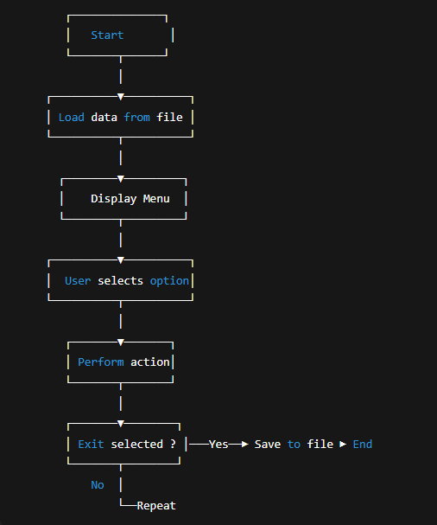
4.3 Algorithms
Algorithm: Add Bus
- Read bus details from user.
- Check if bus ID already exists.
- If not, allocate memory using malloc().
- Insert new bus at end of linked list.
- Display success message.
bus_project
Algorithm: Search Bus by ID
- Traverse linked list.
- Compare node->id with given ID.
- If match found, display details.
- Else, show "Not Found".
Algorithm: Book Seat
- Find bus using ID.
- Check if booked_seats < total_seats.
- If yes: increment booked seats.
- Else: booking failed.
bus_project

5. Implementation Details
5.1 Data Structure Used
The system uses the following structure
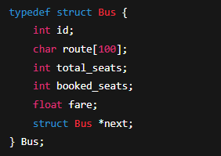
5.2 Important Code Snippets
Creating a Bus
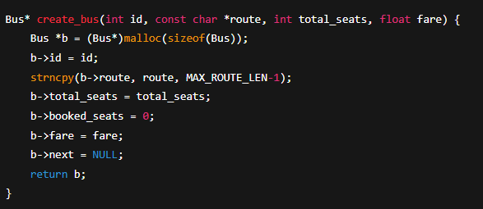
Booking a Seat
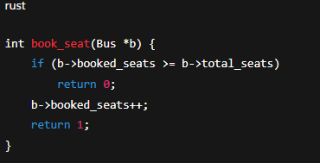
Saving Data to File
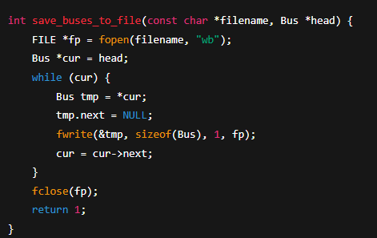
6. Testing & Results
Test Case 1 – Add Bus
Input:
ID: 101
Route: CityA–CityB
Seats: 40
Fare: 120.5
Expected Output: Bus added successfully.
Result: Passed. (Based on sample input)
bus_project

Test Case 2 – Book a Seat
Input:
ID: 101
Expected: "Booked"
Result: Passed (if seats available).

Test Case 3 – Search Route
Input: CityA
Expected: Matching bus displayed.
Result: Passed.

Test Case 4 – File Persistence
Action: Exit program.
Expected: buses.dat updated with latest bus info.
Result: Passed (verified in code).
bus_project

7. Conclusion & Future Work
Conclusion
The Bus Management System successfully demonstrates core programming concepts including:
- Structures and linked lists
- File handling
- Modular programming
- Input validation
- Dynamic memory allocation
It provides an efficient and easy-to-use bus booking and management solution.
bus_project
Future Work
- Add login & admin authentication
- Introduce seat-wise layout display
- Add online payment simulation
- Replace console UI with GUI/Web interface
- Add sorting and filtering options

8. References
- Let us c
- Standard C Library documentation
- Online references for linked lists and file handling

